Digital Program Charter
Project Management Office

Jogi Nijjar, Program Manager, PMO
January 10, 2020
Contents
1.0 Charter Purpose 3
2.0 Program Overview and Objectives 3
3.0 Program Scope 4
In-Scope 5
Out-of-Scope 6
4.0 Benefits and Costs 6
Program Financial Cost Analysis 7
5.0 Key Success Factors 8
6.0 Program Completion Criteria 9
7.0 Constraints and Dependencies 10
8.0 Milestone Timeline 11
9.0 Stakeholders 11
10.0 Risk Summary 13
11.0 Program Governance 14
Program Governance Framework 14
Program Governance Roles & Accountability 14
Program Delivery Governance Framework 15
Program Communications 17
12.0 Approvals 18

Charter Purpose
The purpose of the Program Charter is to provide program stakeholders and senior leadership with:
- An understanding of the program framework
- An outline of the scope and key success factors
- A list of high level milestones and timelines
- A summary of initial assumptions, constraints and risks
- An outline of key roles and responsibilities
- An understanding of related projects
- An estimate of the program costs and immediate budget available

Approval of this Program Charter formalizes the existence of the program and provides the Program Manager with the authority to start work activities. It provides the Program Manager with the authority to direct time and resources to ensure deliverables are met within the program scope.

Program Overview and Objectives
The key goal of the Digital Program is to implement a Digital Client Onboarding platform and processes, and enable the CWB Financial Group to be a disrupter in offering unique Online and Mobile Banking products and services for CWBFG Personal, Small Business, and Commercial banking clients.
Business Objectives and Strategic Alignment
The Digital Program supports the following key strategic objectives:
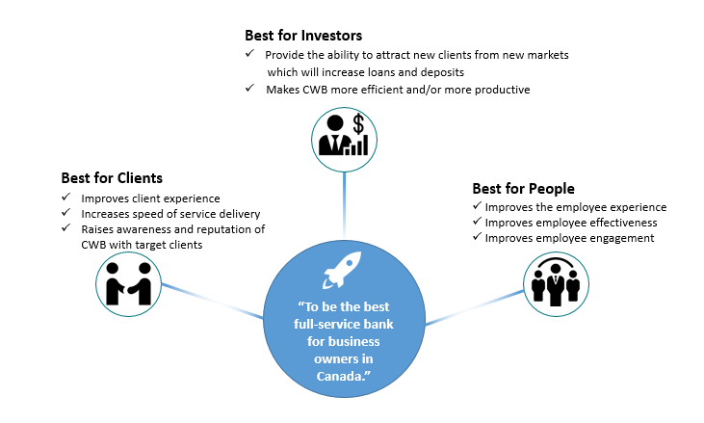

Program Scope
In order to deliver a world-class, seamless, end-to-end digital banking experience for personal, small business and commercial clients, CWB has entered in a partnership with Temenos, Bits In Glass, Thirdstream, and Central 1.
This Program Charter provides an overview of the initial Program scope. A Project Statement will be created for each Program Stream to provide further details on the scope to be delivered for the stream.
Temenos
CWB will be the first bank in Canada to offer a differentiated digital banking experience powered by Temenos Data Lake (Journey Analytics reporting portal) and Temenos Infinity software solution delivering CWB clients an intuitive world-class digital experience.
Temenos Infinity will revolutionize CWB’s digital experience by enabling:
- A fully integrated, highly personalized banking experience tailored to benefit its small business, commercial and personal banking segments
- Accelerated innovation timelines, starting with an digital client onboarding experience followed with a small business banking platform
- Customized insights powered by big data and AI, along with integrated tools, that will help clients more effectively manage their businesses
- Increased access to CWB’s highly-competitive suite of online deposit and cash management products/services from anywhere, anytime
CWB existing Temenos T24 web services will also be further enhanced to support Digital Client Onboarding workflows and enhancements to online banking products/services offered today with Central 1. The goal is to reuse existing web services development where possible and consider the future T24 framework in support of future upgrades, leveraging and building on CWB’s previous investments on the T24 platform.
Bits In Glass
Bits In Glass (BIG) will be the Systems Integrator who will take the lead in implementing the Mulesoft Platform.

Thirdstream
Thirdstream is a fintech company based in Lethbridge, AB that specializes in providing Digital Client Onboarding services for Financial Institutions in Canada. Their system has been selected by the Digital Program to validate the identity of new clients by using a series of third party verification services.

Central 1
Central 1 is a long-term partner who hosts and provides CWB online banking platform services today including payment/settlement processing and reporting. In the Digital Program, CWB will continue leveraging Central 1 as a payment processing/settlement provider through the integration of Central 1’s API for payment/settlement processing, but all clients will be migrated off the existing Central 1 online and mobile banking platforms to the new Temenos Infinity.

The following diagram represents a summary of the various components within the Digital Program in support of Digital Client Onboarding:

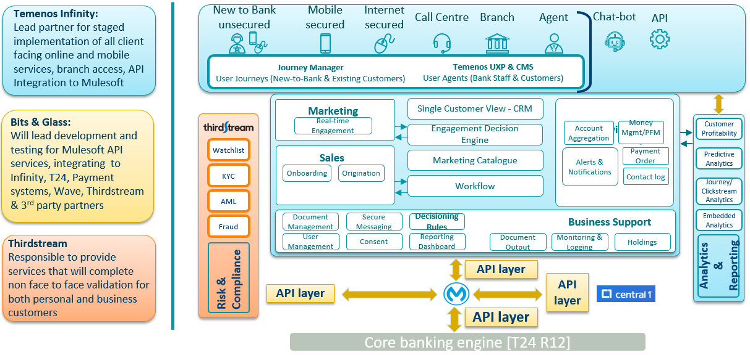

In-Scope
The Digital Program will deliver the following scope via two program streams, using shared and stream-focused CWB resources/partners:

Program Streams and Phases | Description
Program Stream 1 (Digital Client Onboarding):  - Motive Digital Client Onboarding  - CWB Web and In-Branch Personal Digital Client Onboarding  - CWB Web and In-Branch Small Business Digital Client Onboarding  - CWB Small Business Lending | The first key stream is focused on Digital Client Onboarding through the Temenos Infinity platform for prospective Motive, personal and small business clients.  The deployment of the Temenos Infinity Digital Client Onboarding (DCO) Platform (aka. Temenos Avoka) will digitalize the existing and manual client onboarding processes for Motive, personal and small business clients. As part of digitalizing the small business onboarding processes, the ability to offer small business lending will be introduced. Holistically this includes webpage design, workflow management, analytical reporting, integrations (noted below), and user access setup on environments hosted on Temenos Cloud.  This program stream also focuses on the implementation of a Digital integration layer using Mulesoft Platform software. The initial listing of supporting integrations to be orchestrated in support of Personal Digital Client Onboarding through Mulesoft at the time of writing this Charter include:  - Thirdstream: Canada Post (address suggestion, correction and prefill), Amazon SNS (SMS notifications), ThreatMetrix (device and IP fraud screening), IDScan (identity document prefill), Equifax Credit Check, Flinks, Equifax AML Assist/Citadel Fraud, EnStream (mobile phone verification).  - Temenos T24: new web services: create customer, create contact log, create account, create Access Card (PAN( and update PAC code, duplicate customer check.  Note: As needed, additional integrations will be added in support of Small Business Digital Client Onboarding and Small Business Lending.  Finally, this program stream will establish the new CWB Digital Team support and sustainment structure.
Program Stream 2 (Digital Banking Platform):  - Small Business Digital Banking Platform  - Personal Digital Banking Platform  - Commercial Digital Banking Platform | The second key program stream is the implementation of Temenos Infinity digital banking platform product for personal, small business and commercial clients; replacing the existing Central 1 online banking platform that CWB currently uses. This program stream is focused to provide an enhanced client user experience, seamless migration of clients’ accounts, preferences and historical data/transactions, as well as providing additional product/feature/services not available in CWB’s current, Central 1 online banking platform.  This stream will also focus on the integration of Central 1’s API for payment/settlement processing services through the Mulesoft Platform and enhancement of T24 web services as needed.  Note: In support of the future state platform product/service functionality to be offered, this stream will include additional banking platform integrations.
Note: Detailed scope clarification/business requirements will be defined at the start of each phase.

Out-of-Scope
The following items are considered to be out of scope of this program:

- CWB Partner Companies use of these solutions (outside Motive and CWB);

Note: Out of scope statements for each of the Program Stream phases will be clarified at the start of each phase.

Benefits and Costs
Delivering the scope of the program is expected to deliver tangible and intangible benefits as per the PMO’s Reportable Benefit Guideline. The following are the guiding principle benefits that will be further expanded upon as part of each program stream phase implementation:

Best for Investors:
- Deliver tools, products and features to small business clients that will deepen existing relationships and attract new clients to CWB.
- Reduce manual efforts that are currently required to open new accounts, and improve compliance and data integrity.
Best for Clients:
- The modern and distinct products/services that will be delivered by the Digital Program will improve client experience though improving the functionality of the online systems, and offering clients tools they don’t have access to elsewhere.
- Digital Client Onboarding will offer personal and small business clients a much faster way to open a new account remotely, which will benefits prospective new clients who are outside of CWB’s current geographic branch footprint.
- Implement a new digital platform targeted for small business clients to help them manage all aspects of their business and save time.
- Establish a marketplace of integrated and non-integrated partners who offer best in class services curated by CWB.
- Be a single point of access for our clients for both Financial and non-Financial services.
Best for People:
- Reducing manual efforts required by CWB staff will improve the employee experience and allow them to focus on more value-add activities.
- Staff are clients of the bank, and will benefit from the improved experience that will be delivered by the personal changes in the Digital Program, and in particular the enhancements to personal digital banking.
A detailed description of the agreed reportable level benefits and applicable owners will be added prior the launch of each project phase implementation and tracked centrally in the Digital Program’s Benefit Tracker. The Program Manager will work with the Program Owners/Digital Delivery Lead to schedule and facilitate the reportable benefit definition reviews and updates to the Benefit Tracker accordingly. Post implementation, benefit realization updates and results will be reported to the CWBFG Project Steering Committee (PSC) in accordance to the defined benefits realization dates.

Program Financial Cost Analysis
The following is a summary of the forecasted Program implementation costs viewed at the time of writing this Program Charter:
Source | Amount
Capital (FY20) – Approved | $3,600,000
NIE (FY20) – Approved | $3,400,000
TOTAL | $7,000,000
Source | Amount
Capital (FY21) - Preliminary Forecasted | $5,000,000
NIE (FY21) - Preliminary Forecasted | $2,000,000
TOTAL | $7,000,000
NOTE: The FY21 budget noted above will be refined during the yearly PMO Project Roadmap process with Executive Committee (ExecCo)/PSC/Finance.
Considering the estimated FY20 and forecasted FY21 costs above, the overall costs for the Digital Program can be summarized as follows:
Measure | Result | CAP/NIE | Comment
Implementation Costs (FY20/FY21) | $ 7M / $7M | Combined Capital and NIE
Annual On-going Cost Summary (5 year view) | $ 10M | NIE | Assuming an annual cost of $ 1,000,000 (Mulesoft, Temenos, and Thirdstream support) and $ 1,000,000 (new CWB Digital and IS - Integration support staff resources).
Total | $24M

Key Success Factors
In order for the Digital Program to be successful, the following conditions must exist:
Scope | Products and service offerings being introduced as part of the Digital Program must enable a sustainable competitive advantage for CWB with focus on Small Business segmentations.
Clients | Existing clients of CWB’s online banking platform must experience a seamless, easy transition onto the Temenos Infinity Digital Banking Platform. Users’ information, historical data, transactions and preferences must be migrated and be available at all times.
Resources | The Digital Program will require the involvement of several teams within CWB and its Digital Partners, some of which need to be dedicated to the program full-time. Subject Matter Experts (business and technical) must have the required and specific level of knowledge/experience needed to develop the associated implementation deliverables and be available to complete/support sustainment.
Leadership | To manage the successful introduction of the Temenos Infinity Digital Client Onboarding processes and transition to the Digital Banking platform, leaders who understand CWB’s processes, products, services, and applications as well as the impacts of the change introduced by this Program will be needed at all levels, from executive to administrative. Executive Sponsors and Program Owners must provide visible, demonstrable, and sustained endorsement through each program stream phase.
Priorities | The Digital Program must be regarded as a high-level priority. Conflicts between the Digital Program and other projects or operational work activities may affect the success of the Program.
Effective Decision Making | The decision-making structure must be agile, accessible, and responsive to the complex needs of the Program. Decisions must be made in a timely manner and in the clear context of enterprise-level goals and objectives. The Program Owners and associated delegated leads are the primes.
Communications | Communications is the lifeline of complex change. Sustained and focused communication to all stakeholders (internal and external) throughout the Digital Program must be of the utmost importance.
Methodology | CWB and its Digital Partners must find a way to align various methodologies, from waterfall to agile, in order to reliably deliver the business requirements defined.
Sustainment | There must be resources (Digital team, IS, Client Solutions and OCM) allocated to sustainment of solutions beyond Program closure or operational implementation.
Compliance | Continual engagement with Regulatory Compliance must take place to ensure that all solutions and services are compliant with all regulations for consumer protection and fraud protection. This will mitigate significant risks to the Program success as well as to CWB’s reputation and bottom line.
Internal Guidelines | In addition to the above, the Program and its components will follow the PMO Project Guiding Principles.

Program Completion Criteria
The program will be considered complete based on the following criteria:
- Program Acceptance: All of the agreed project phases, defined within the Digital Program Roadmap, have been implemented and formally accepted by the identified Program Owners. Stabilization periods defined under each project phase have been achieved.
- Benefits Realization: All of the business outcomes/benefits that are identified through the individual project phases under the Digital Program ahead of implementation launch are accounted for (either achieved, eliminated, or enabled with assignment to the appropriate benefit owner for reporting).
- Lessons Learned: A formal Post Implementation Review (PIR) has been completed for the Digital Program and the Lessons Learned identified, documented, communicated and properly archived.
- Program Closure: Formal Program Closure approval received by the identified governing body and all applicable resources, tools, 3rd party contracts, and related Program artifacts have been archived, re-allocated, transitioned, and / or cancelled.

The program will be considered successful based on the following criteria:
- Scope
- Products and services offerings from CWB’s Digital Partners (Temenos, Thirdstream, BIG and Central 1) are delivered in accordance with the formalized agreements and accepted by the Project Owners and associated sustainment leads;
- Clients’ data, transactions, existing products/services setup, and preferences are seamless migrated onto the Temenos Infinity Digital Banking platform, minimizing outages for clients;
- Features currently available in CWB’s Online Banking platform will remain available in the Temenos Infinity Digital Banking Platform;
- Eliminate or minimize future “technical debt” by ensuring that third party services are properly integrated to each product introduced as part of the Digital Program through either the Mulesoft Platform or other platform integration;
- Enablement of new business features/services offered;
- No client impacts in providing like-for-like features/services;
- Program Change Requests (CRs) are properly evaluated and approved.

- Quality
- Program and project plans are effectively managed in accordance with the expectations of the Program Owners, Executive Sponsors, and in keeping with CWB’s Project Management Office and People 1st practices and policies;
- Key stakeholders are satisfied with the process and system changes that have been implemented;
- Regulatory compliance guidelines for all scope have been met;
- Each project phase has clear, measurable benefits that support the organizational goals, and that the benefits are enabled upon launch;
- Impacted stakeholders and end users demonstrate a high level of change adoption;
- An ongoing sustainment and support governing body is established to oversee operational and solution sustainment changes.

- Cost
- Program is delivered within the approved budget, including approved Program CRs.

- Time
- Program is delivered within the planned schedule;
- Program CRs are properly evaluated and approved.

Constraints and Dependencies
A significant part of the Digital Program will be the identification and management of dependent projects and operational initiatives. In the early stages of the program, a dependency assessment will be conducted to identify any activities (in-flight and planned) that will have an impact on, or be impacted by, the Digital Program.
The outcome of the dependency assessment will be a recommendation for each dependent project or operational initiative to either: continue as planned, continue under the program, or be cancelled/postponed. The assessment will consider all regulatory or risk-related requirements.
Dependency Assessment Approach
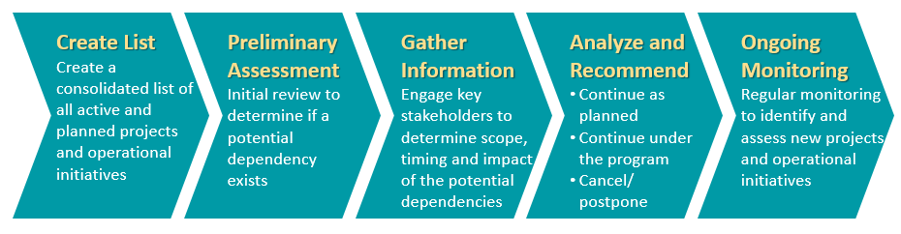
The dependency assessment and on-going management plan will be co-led by the Digital Program (Program Owners, Program Manager, OCM Lead, and Partner PMs). After the initial assessment is complete, the Digital Program (the aforementioned team members) will continue to assess new projects/operational initiatives as they are raised to ensure that there is continued visibility to all related dependencies.
The following are the initial and key dependency program, projects, and operational work items identified at the time of writing this charter:
Program/Project/Operational Work Items | Description
Enhancement Leadership Team | Any changes/enhancements that are not related to a project that are considered by the Enhancement Leadership Team must be evaluated for impacts to the Digital Program.
T24 Virtualization | As the T24 application moves onto a virtualized environment, the timing of this move needs to be taken in consideration to prevent any critical T24 integration from being missed or broken.
Business Process Review Program | As credit processes are being reviewed and optimized, some of these process changes may impact client opening processes and/or any of the solutions planned in the Digital Program.
Digital Integration & Enhancements | Mulesoft will be the middleware between the new solutions introduced by the Digital Program and existing applications and data within CWB environment. The Digital Integration & Enhancements project will enable Mulesoft and the connectivity with CWB’s applications and data sources.
Forms Enhancements – Phase 1 | Forms developed to support many business processes are being reviewed, redesigned or decommissioned. As some of these forms may be associated with the client opening and/or digital banking processes and solutions, this dependency needs to be taken in consideration.
Identity and Access Management | CWB is implementing new policies, procedures and applications to support its cyber-security program. The solutions implemented under the Digital Program will be leveraging this new security solution, therefore this project needs to be monitored closely.

Milestone Timeline
The following are the major program milestones and timelines identified at this time. As the program planning moves forward and the schedule is developed, checkpoints will be established to confirm the milestones and their target completion dates. Detailed timelines/scheduled will be developed at the start of each program stream phase and deliverables tracked throughout the associated implementation timeline.
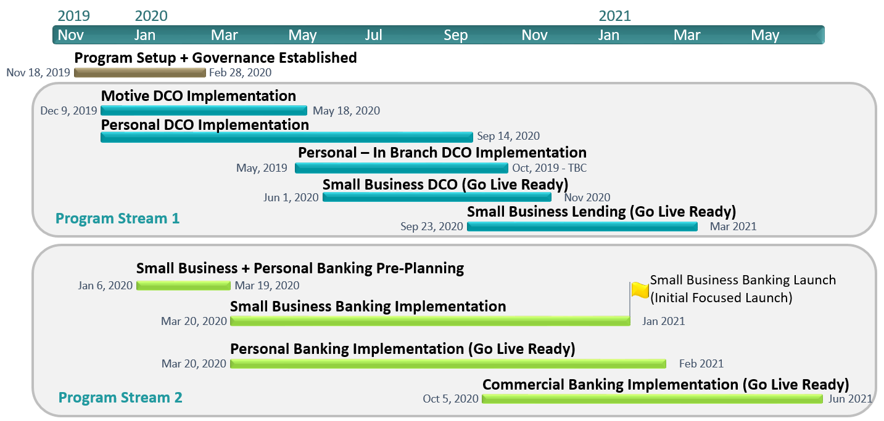

Stakeholders
The Digital Program is a complex undertaking that affects numerous and diverse groups of stakeholders. The following table represents the primary Stakeholder groups that will play a continual role throughput the Program.
Based on the output of the Digital Program Stakeholder Register, the Stakeholder groups that will be engaged to deliver the scope of the program as well as those that will be impacted post implementation have been identified and documented as follows:
Stakeholder Group | Role on Program | Level of Program Engagement  (H\M\L) | Level of Operational Impact (H/M/L)
AML – Regulatory Compliance | SME / UAT Support | M | M
Banking Operations | Program Delivery | M | L
Bits In Glass (CWB’s Digital Partner) | Program Delivery and Sustainment | H | L
Branch Staff | SME / UAT Support | L | M
Branches/Regional Management | Program Delivery | M | L
CAPE | Program Delivery | L | L
Central 1 (CWB’s Digital Partner) | Program Delivery | H | L
Centralized Services | SME / UAT Support | L | L
Client Solutions | Program Governance & Delivery | H | H
Consumer Protection / Privacy | SME / UAT Support | M | M
Corporate Communications | Program Delivery | M | L
Customer Experience | Program Delivery | M | L
Finance | Program Support | L | L
Fraud and Special Investigation Services | SME / UAT Support | M | M
HR - Workday | SME / UAT Support | L | L
Information Services | Program Governance & Delivery | H | M
Integrated Risk Management | Program Support | L | L
Learning and Development | Program Delivery | L | L
Legal | SME / UAT Support | L | L
Marketing | Program Delivery | M | L
Digital & Alternate Channels (including Motive Financial) | Program Delivery | H | H
Organizational Change Management | Program Delivery | H | L
Program Management Office | Program Governance & Delivery | H | L
RDAAR | SME / UAT Support | L | L
Regulatory Compliance | Program Delivery | M | M
Temenos (CWB’s Digital Partner) | Program Delivery & Sustainment | H | L
Thirdstream (CWB Digital Partner) | Program Delivery | H | L
Treasury | SME / UAT Support | L | L

The initial stakeholder groups identified in the above table were pulled from the Digital Client Onboarding project phase initial New Initiative/Change Risk Assessment Process assessment (NI-RAP). A separate NI-RAP for each Program Stream project phase will be developed where there is material change in the operational risk profile or impacted stakeholder groups in comparison to the Program Stream’s initial NI-RAP that the project phase belongs to.

Risk Summary
The following high level risks identify events that could prevent the full realization of the project benefits. The Risk Likelihood and Risk Impact of each risk has been identified for both the initial view, where no controls or other mitigating factors are applied, as well as the residual view that remains after controls are applied. These risks, and new risks identified as the program progresses, will be tracked using the PMO’s Project Management system and reported accordingly. They will be reviewed and updated on a regular basis with the Program Team, Partners, Project Owners, Executive Sponsors, and Executive Steering Committee.

Risk Category & Details | Initial View |  | General Mitigation Strategy | Residual View
Risk Category & Details | Probability | Impact |  | Probability | Impact
Availability of internal CWB and external Partner resources | High | Very High | Identify program resourcing needs early and expedite onboarding. Plan for adequate backup resources and knowledge transfer. Stagger out tasks/asks if not critical path to better balance key business/technical resources. | High | High
Tight delivery schedules | High | Very High | Ensure all teams remain aligned with the Temenos schedules and focused in identifying key dependencies/closing out critical path items. | High | High
Management of cross dependencies between/within the partner solutions | Very High | Very High | Enable effective cross-group communications, build a collaborative 'one-team' Partner approach to ensure upfront alignment and avoidance of rework. | High | High
Uncertainty in Partner product solutions and services adds risks to the schedule | High | High | Make sure CWB existing scope is clearly defined upfront, work with Partners as early as possible to validate the functionality available in each applicable product and/or service, ensure contract scope includes support for existing CWB business functions. | High | High
The schedule will be at risk if the solution requires significant customization | Medium | Very High | This risk is being mitigated by confirming as soon as possible the customizations required. | Low | Low

Program Governance

Program Governance Framework
Establishing an effective governance framework is critical and will enable the success of the Program. Program Governance addresses the following needs:
- Continuous linkage to enterprise business strategy and direction  - Decisions appropriately aligned with organizational objectives and principles and they are occurring at the appropriate level  - Clear and well-understood decision-making authority and accountability  - Effective oversight of and insight into Program progress and direction  - Executive insight and decision control over Program evolution and outcomes  - Enablement and tracking of benefits realization  - Program progress, risks and issues are being effectively managed | Executive  Steering Committee  Sponsor Oversight Group  Program Owners  Direction and Decisions  Options and Analysis

Program Governance Roles & Accountability

Executive Steering Committee
The Executive Steering Committee will be made up of Executive and Sr. Management stakeholders who are given authority and accountability for setting strategic direction for the Program, defining key success metrics, prioritization (time, scope, and budget) and monitoring the Program.
Membership, authority, boundaries and other information about the Digital Program’s Executive Steering Committee can be found in the Digital Program’s Terms of Reference for the Executive Steering Committee.
Sponsor Oversight Group
The Sponsor Oversight Group is comprised of members of the Client Solutions and Information Services Executive teams, who will act as liaison with other members of the Executive team, taking responsibility to champion, guide and monitor the program implementation and stabilization periods until sustainment is achieved, ensuring that the program delivers on the enterprise requirements and defined success criteria.

Program Owners
The Program Owners are the lead people accountable to the Sponsor Oversight Group and the Executive Steering Committee for the success of the Program. The Program Owners have the overall accountability for Program delivery, including scope, budget, schedule, resources and stakeholder management. The Program Owners will report directly to the Executive Sponsors and will be the Chair of the Program Advisory Group.

Program Delivery Governance Framework
The following diagram shows the relationship between Program Governance and Program Delivery Governance.

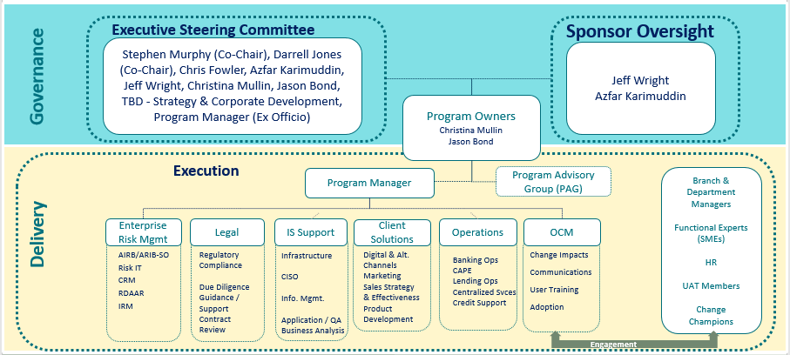

Program Advisory Group
The Program Advisory Group will consist of VP and AVP level members from the business and operations, who will be invited to provide input to the program. They will provide support as required on Program decision requests, strategy, and/or provide key information and materials in support of finalizing Program deliverables and/or post sustainment ownership structures. The Program Advisory Group will be chaired by the Program Owners.
Program Management
The Program Manager is responsible for managing the delivery for the program. This role has operational responsibility over all Program team members, engaged Stakeholders, and Third Party Vendors (CWB Partners) in leading the delivery of the Program, ensuring objectives and benefits are accomplished within approved budget, timeline, and scope. This role integrates efforts, continuously assesses and refines approaches and plans. For the program engagement, the Program Manager will report to the Program Owners and works with oversight from the PMO related to best practices and support processes as measured through the PMO Stage Gate Control process.
Further Details about the Program roles and responsibilities can be found in the Digital Program Roles and Responsibilities document.

Program Management Plan
This Program will follow the program and project management processes established by the PMO as defined in the Digital Program Management Plan. Exceptions to this plan will be added to this section as required for review and approval as part of the approval of this Program Charter.
Program Mgmt. Deliverable / Process Impacted | Describe the Exception | Reason for the Exception
NI-RAP | A NI-RAP assessment will be created for each Program Stream and expanded upon as needed | Program stream phases may result in material changes to the operational risk and/or impacted stakeholder groups and requires a new specific NI-RAP created (assessed case by case)
Program Charter | Project Statements will be created for each phase within each Program Stream instead of project charters | This Program Charter defines the overarching governance, processes and controls to be adopted by all projects within the Program. Therefore, Project Statements will be created to clarify the phase scope, timelines, roles/responsibilities, risks, dependencies, assumptions, communication plan changes, and any other information that is not already covered by/aligned with this Program Charter.
Benefits | Benefits will be defined and approved prior to implementation of each Program Stream phase | Given the unique characteristics of this Program and end state solution unknowns, benefits will be defined based on the Program Charter’s overarching guiding benefits and centrally stored in the Program’s Benefit Tracker. Benefits may be defined, refined and updated at the beginning, during or at the end of each phase within the Program Streams.
Resource Plans | Resources will be defined and managed at the Program level | As the Program team will be comprised of cross-functional resources that are going to be shared in most cases between the two Program Streams, resource management will be kept at the Program level.
Program Delivery Strategy | A program delivery strategy will not be created for this Program | Project Statements for each program phase will clarify the roles and responsibilities of key team members that is typically clarified via the Project Delivery Strategy. Therefore, there is no need to create this deliverable.
Program Budget Tracker | Financial tracking will be performed at the Program level | The program manager will centrally track the budget/costs for all phases within this Program. Related costs will be charged to the applicable budget codes setup by Finance.
Program Stream Lessons Learned | Lessons learned will be gathered and reviewed at the end of each program stream phase | In order to capitalize on lessons for future phases, lessons learned will be gathered, discussed and documented at the end of each Program Stream phase vs. end of the Program.
Program Stream Closure Report | A Program Stream Closure Report will be developed to formalize the completion of each Program Stream instead of a project closure report at the end of each phase within the same Program Stream | In order to maximize efficiency, A Program Stream Closure Report will be developed and approved by the Program Owners and Executive Sponsors to formalize the completion of each Program Stream. This will replace the need of creating and approving project closure reports for each phase within the same Program Stream.

Program Communications
Program communications will be formalized through key Program management meetings and the distribution of key Program management deliverables. By approving this Charter, the Executive Sponsors and Program Owners commit time to the following Program management meetings identified in the table below:

Participants  Meeting Name | Sponsors  Oversight Group | Executive Steering Committee | Program Owners | Program Advisory Group | Program Manager | Project Manager | Program Team | Digital Partners | PMO | Frequency
Program Kickoff |  |  |  |  |  |  |  |  |  | As needed to engage new phase scope / teams
Executive Steering Committee Update |  |  |  |  |  |  |  |  |  | Monthly
Executive Sponsors Update |  |  |  |  |  |  |  |  |  | Monthly
Program Advisory Group Decision Meeting |  |  |  |  |  |  |  |  |  | Monthly (as required)
Program Owners Status Update |  |  |  |  |  |  |  |  |  | Weekly
Partner Status Update |  |  |  |  |  |  |  |  |  | Weekly
Sprint Planning |  |  |  |  |  |  |  |  |  | At the beginning of each sprint
Daily Scrum |  |  |  |  |  |  |  |  |  | Daily
Sprint review and retrospective |  |  |  |  |  |  |  |  |  | At the end of each sprint
Program Team Status Update |  |  |  |  |  |  |  |  |  | Weekly or as required
Deliverables Review/Approval |  |  |  |  |  |  |  |  |  | As required
PMO Oversight (1:1) |  |  |  |  |  |  |  |  |  | Bi-Weekly
PMO Dependencies and Risks |  |  |  |  |  |  |  |  |  | Monthly

Each Program Stream phase within the Digital Program may require additional meetings and/or changes to the meetings above. If so, this will be documented within the project statement accordingly for the applicable phase.
Descriptions of the key Program management deliverables and meetings are available in the Digital Program Management’s Communications Framework.

Approvals
Digital or hard copy sign-off is required from the following to proceed:
Jeff Wright, Sr. VP Client Solutions  Executive Sponsor |  | Digital Approval  (Double Click and select ‘checked’ under Default) |  | Date
Azfar Karimuddin, VP Information Services  Executive Sponsor |  | Digital Approval  (Double Click and select ‘checked’ under Default) |  | Date
Christina Mullin, VP Digital & Alternative Channels  Project Owner |  | Digital Approval  (Double Click and select ‘checked’ under Default) |  | Date
Jason Bond, Sr. AVP Application Services  Project Owner |  | Digital Approval  (Double Click and select ‘checked’ under Default) |  | Date
Kenneth Mastaller  Sr. AVP, PMO |  | Digital Approval  (Double Click and select ‘checked’ under Default) |  | Date
Bruno Freitas  AVP, Program Management |  | Digital Approval  (Double Click and select ‘checked’ under Default) |  | Date
Jogi Nijjar  Program Manager |  | Digital Approval  (Double Click and select ‘checked’ under Default) |  | Date
Barb Keryliuk  Sr. Manager, PMO |  | Digital Approval  (Double Click and select ‘checked’ under Default) |  | Date

